UNIVERSITY OF NIGERIA, NSUKKA
FACULTY OF ENGINEERING
DEPARTMENT OF ELECTRICAL ENGINEERING

AN ASSIGNMENT SUBMITTED IN PARTIAL FULFILMENT FOR THE REQUIREMENT OF THE COURSE EEE 354 (MEASUREMENT AND APPPLIED ELECTRONICS LABORATORY)

BY
IGOLO VICTORY SAMUEL
2017/247148

LECTURER: ENGR. UMEOGAMBA A.I.

MAY, 2021

NAME: IGOLO VICTORY SAMUEL
REG NO.: 2017/247148
COURSE CODE: EEE 354

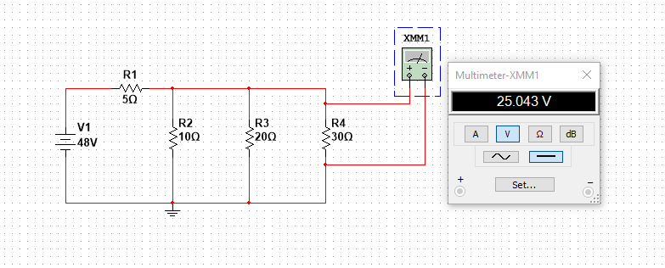

NAME: IGOLO VICTORY SAMUEL
REG NO.: 2017/247148
COURSE CODE: EEE 354

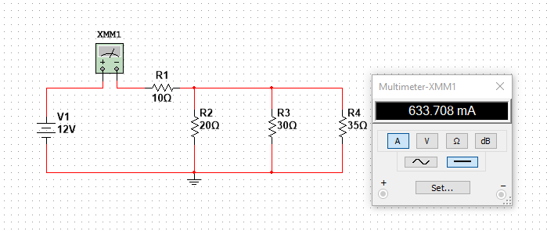

NAME: IGOLO VICTORY SAMUEL
REG NO.: 2017/247148
COURSE CODE: EEE 354

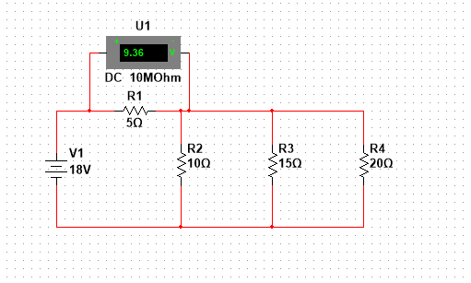

NAME: IGOLO VICTORY SAMUEL
REG NO.: 2017/247148
COURSE CODE: EEE 354

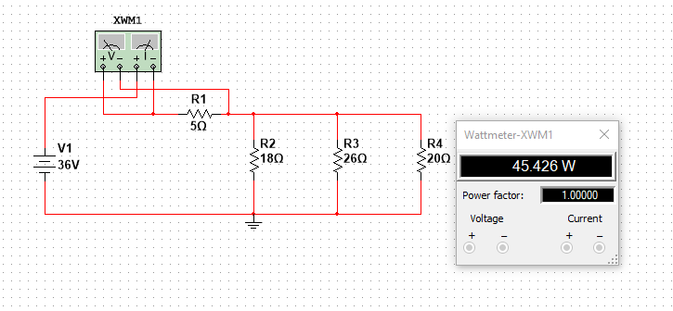

NAME: IGOLO VICTORY SAMUEL
REG NO.: 2017/247148
COURSE CODE: EEE 354
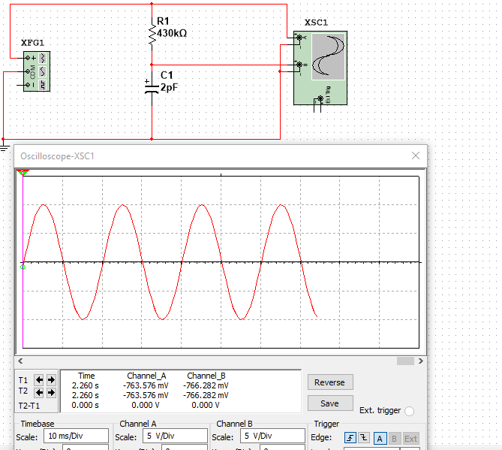

NAME: IGOLO VICTORY SAMUEL
REG NO.: 2017/247148
COURSE CODE: EEE 354
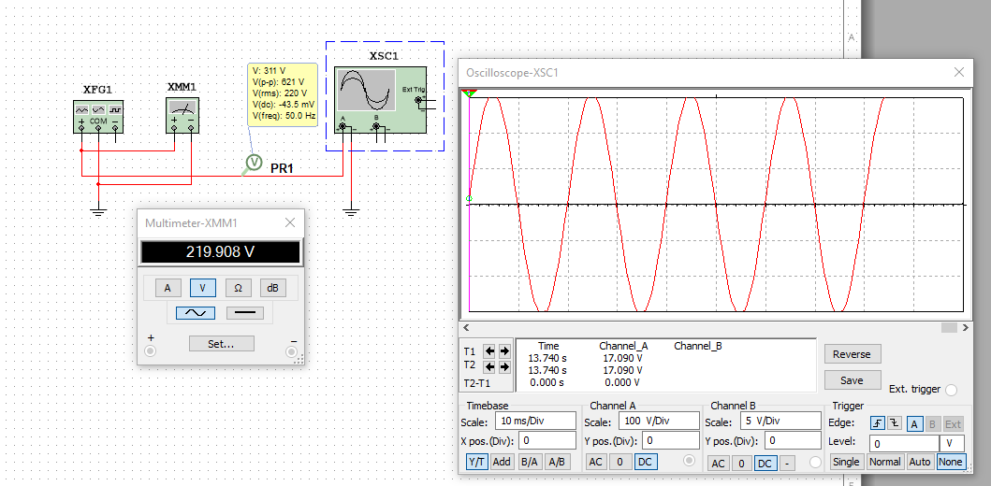

NAME: IGOLO VICTORY SAMUEL
REG NO.: 2017/247148
COURSE CODE: EEE 354

